------------------------------------------------------------------------------
EX.NO:16a.PHP script to illustrate function
------------------------------------------------------------------------------
Aim: To Write a PHP function to find unique values from multidimensional arrays and flatten them in 0 depth.
Source Code:
<?php
function array_flat($my_array)
{
$fa = array();
$l = 0;
foreach($my_array as $k => $v )
{
if( !is_array( $v ) )
{
$fa[ ]= $v;

continue;
}
$l++;
$fa= array_flat( $v, $fa, $l );
$l--;
}

if( $l == 0 ) $fa = array_values( array_unique( $fa ) );
return $fa;
}
$tmp = array( 'a' => array( -1,-2, 0, 2, 3 ), 'b' => array( 'c' => array( -1, 0, 2, 0, 3 ) ) );
print_r(array_flat($tmp));
?>
Output:
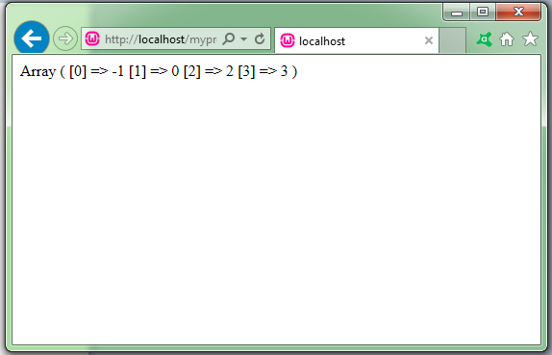
------------------------------------------------------------------------------
EX.NO:16b. Form data using PHP
------------------------------------------------------------------------------
Aim: To handle the form data using PHP
Source Code:
<!DOCTYPE HTML>
<html>
<head>
<style>
.error {color: #FF0000;}
</style>
</head>
<body>

<?php
// define variables and set to empty values
$nameErr = $emailErr = $genderErr = $websiteErr = "";
$name = $email = $gender = $comment = $website = "";

if ($_SERVER["REQUEST_METHOD"] == "POST") {
if (empty($_POST["name"])) {
$nameErr = "Name is required";
} else {
$name = test_input($_POST["name"]);
}

if (empty($_POST["email"])) {
$emailErr = "Email is required";
} else {
$email = test_input($_POST["email"]);
}

if (empty($_POST["website"])) {
$website = "";
} else {
$website = test_input($_POST["website"]);
}

if (empty($_POST["comment"])) {
$comment = "";
} else {
$comment = test_input($_POST["comment"]);
}

if (empty($_POST["gender"])) {
$genderErr = "Gender is required";
} else {
$gender = test_input($_POST["gender"]);
}
}

function test_input($data) {
$data = trim($data);
$data = stripslashes($data);
$data = htmlspecialchars($data);
return $data;
}
?>

<h2>PHP Form Validation Example</h2>
<p><span class="error">* required field.</span></p>
<form action="<?php echo htmlspecialchars($_SERVER["PHP_SELF"]);?>" method="post">
Name: <input type="text" name="name">
<span class="error">* <?php echo $nameErr;?></span>
<br><br>
E-mail: <input type="text" name="email">
<span class="error">* <?php echo $emailErr;?></span>
<br><br>
Website: <input type="text" name="website">
<span class="error"><?php echo $websiteErr;?></span>
<br><br>
Comment: <textarea name="comment" rows="5" cols="40"></textarea>
<br><br>
Gender:
<input type="radio" name="gender" value="female">Female
<input type="radio" name="gender" value="male">Male
<span class="error">* <?php echo $genderErr;?></span>
<br><br>
<input type="submit" name="submit" value="Submit">
</form>

<?php
echo "<h2>Your Input:</h2>";
echo $name;
echo "<br>";
echo $email;
echo "<br>";
echo $website;
echo "<br>";
echo $comment;
echo "<br>";
echo $gender;
?
</body>
</html>

Output:
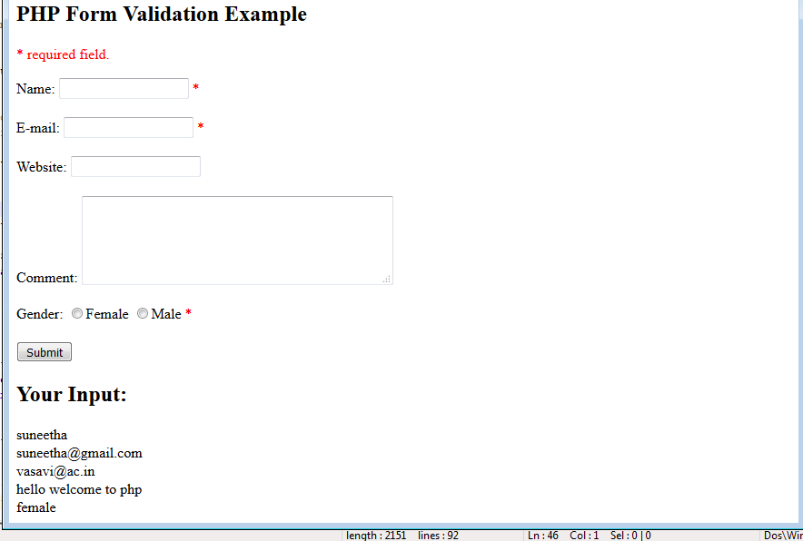

------------------------------------------------------------------------------
EX.NO:16c. Cookies
------------------------------------------------------------------------------Aim: To Check if cookies are enabled using PHP
Source Code:
<!DOCTYPE html>
<?php
$cookie_name = "user";
$cookie_value = "Suneetha Jonnadula";
setcookie($cookie_name, $cookie_value, time() + (86400 * 30), "/");
?>
<html>
<body>

<?php
if(!isset($_COOKIE[$cookie_name])) {
echo "Cookie named '" . $cookie_name . "' is not set!";
} else {
echo "Cookie '" . $cookie_name . "' is set!<br>";
echo "Value is: " . $_COOKIE[$cookie_name];
}
?>
<p><strong>Note:</strong> You might have to reload the page to see the new value of the cookie.</p>
</body>
</html>
Output:
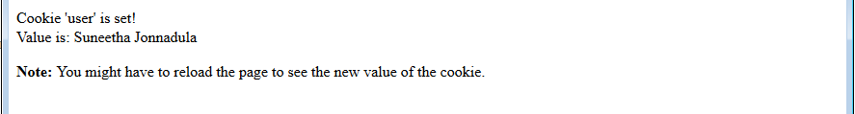

------------------------------------------------------------------------------
EX.NO:17. Database Connection using PHP

------------------------------------------------------------------------------

Aim
Create tables in the database which contain the details of items (books in our case like Book name , Price, Quantity, Amount ) of each category. Modify your catalogue page (week 2) in such a way that you should connect to the database and extract data from the tables and display them in the catalogue page using PHP

Description

The CREATE TABLE statement is used to create a table in MySQL.
Syntax
CREATE TABLE table_name
(
column_name1 data_type,
column_name2 data_type,
column_name3 data_type,
....
)
We must add the CREATE TABLE statement to the mysql_query() function to execute the command.

Create a Connection to a MySQL Database
Before you can access data in a database, you must create a connection to the database.
In PHP, this is done with the mysql_connect() function.
Syntax
mysql_connect(servername,username,password);

Closing a Connection
The connection will be closed automatically when the script ends. To close the connection before, use the mysql_close() function:

Select Data From a Database Table
The SELECT statement is used to select data from a database.
Syntax
SELECT column_name(s)
FROM table_name
To get PHP to execute the statement above we must use the mysql_query() function. This function is used to send a query or command to a MySQL connection.

Source Code

Create Table Syntax in MySQL

CREATE TABLE ivcse.items (
booknameVARCHAR(30)NOTNULL,
authorVARCHAR(30)NOTNULL,
publisherVARCHAR(35)NOTNULL,
priceDECIMALNOTNULL
);

Inserting data into items table.

INSERT INTO `ivcse`.`items` (`bookname`, `author`, `publisher`, `price`) VALUES ('XML Bible', 'Winston', 'Wiely', '40.5');

INSERT INTO `ivcse`.`items` (`bookname`, `author`, `publisher`, `price`) VALUES ('AI', 'S.Russel', 'Princeton hall', '63');

INSERT INTO `ivcse`.`items` (`bookname`, `author`, `publisher`, `price`) VALUES ('Java 2', 'Watson', 'BPB publications', '35.5');

INSERT INTO `ivcse`.`items` (`bookname`, `author`, `publisher`, `price`) VALUES ('HTML in 24 hours', 'Sam Peter', 'Sam publication', '50');

Catalogue.php
<?php
$con = @mysqli_connect("localhost","root","");
if (!$con)
{
die('Could not connect: ' . mysqli_error());
}

mysqli_select_db($con,"mydb");

$result = mysqli_query($con,"SELECT * FROM items");

echo "<table border='1' width='100%'>
<tr>
<th>Snap shot of Cover Page</th>
<th>Book Name <br>Auther Name<br>Publisher</th>
<th>Price</th>
<th>Add to Cart</th>
</tr>";

while($row = mysqli_fetch_array($result))
{
echo "<tr>";
echo "<td><img src='images/". $row['bookname'] . ".jpg' width=50 height=50></td>";
echo "<td>Book :" . $row['bookname'] . "<br>Author :" . $row['author'] . "<br>Publication :" . $row['publisher'] . "</td>";
echo "<td>$" . $row['price'] . "</td>";
echo "<td><img src='images/cart.png' width='75px' height='30px' align='middle'> </td>";
echo "</tr>";
}
echo "</table>";

mysqli_close($con);
?>Output:
